 | 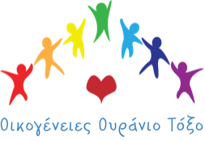 | 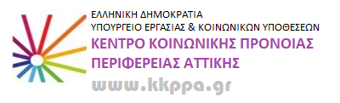

“Same-sex parenting for the best interests of the child”. Capacity building seminar conducted at the Greek National Center for Welfare in Attica (KKPPA).
Training social workers and psychologists responsible for adoption and foster care at the KKPPA in Greece, aims at raising awareness and increasing capacity in the workforce in better handling applications for foster care and adoption in LGB couples and/or individuals as well as providing the best support possible for LGB couples or single parents along the way. Specifically, through training it is expected that participants will increase their knowledge in understanding matters relating to gender, sexual orientation, gender identity and gender-based stereotypes as well as understand the challenges for LGB couples and single-parent candidates for foster care or adoption.
The seminar constitutes of 6 meetings (2h each) which will take place bi-weekly. During these meetings, evidence-based inclusive practices will be presented relating to LGB families in Greece as well as in the EU. For that cause, Rainbow Families (Greece) will also participate through their experience through Stella Belia, president of the organization, and selected members of the organization. Sharing common values with the Network of European LGBTIQ* Families Associations (NELFA) who officially endorse this training, members from the network will also contribute through online participation of its president Eleni Maravelia as well as through recorded messages from the wider network.
Coordination of the training activities lies with Eirini Koutela, trained psychotherapist and mental health counsellor as well as Michalis Lavdas, psychologist who are both specialized in raising awareness for LGBTI issues.
The expected results of the training activities involve facilitating an inclusive, human-centered approach for LGB families as well as reducing gender-based discrimination. Finally, it is expected that such training activities will act as a “gateway” for further reform in foster care and adoption services in Greece eventually pushing for more LGB friendly policies and practices at a country-level.
A message from the Greek organizations Rainbow Families follows: It is with great joy that we accepted the invitation to participate and contribute to the capacity building for same-sex parenting for the best interests of the child in collaboration with KKPPA and to discuss about our experience as LGBTQI+ parents who raise our children in Greece so that we can help the professionals working in adoption and foster care deconstruct prejudice and stereotypes that relate to myths around parenting in LGBTQI+ people. We hope that our participation contributes to the effectiveness of the training, helping achieve the goals of making it perfectly clear and accepted that sexual orientation, gender identity, gender expression and characteristics of someone do not relate in any way with the capacity of being a suitable parent and child carer. In this way, we hope that chances increase for all the children to find a home they deserve growing up with people that raise them with love and care.

